JUBAIL UNIVERSITY COLLEGE- FEMALE BRANCH
ENGL 118- ENGLISH COMPOSITION II
Semester 392
ENGL 118 Term Paper Guide
NOTE:
- Submit your term paper (APA style), your rough draft, and all your other preparatory work by the due date.
- The supervisor will make comments on the FIRST DRAFT. It is your responsibility to revise and edit it.
- Do not allow yourself to be accused of plagiarism.
- Your research paper should be based on one of the topic choices (see page 3). The paper should reflect an opinion that supports one side of an argument, or think about a problem that needs a solution, or an issue that we experience in our world or as a college community, or a question that you would like to answer. Then use your research to offer a solution to the problem, provide an opinion on the issue, or answer the question. This paper must include at least four sources.
- Word Count: 2000 words
Introduction

Approved Sources and Categories:

Print Sources
- Books
- Scholarly Journals
- Dictionaries
- Encyclopedias
- Interviews
- Textbooks
- Surveys

Electronic Sources
- Electronic Databases
- Websites (ending in org. edu.gov.)
- Electronic encyclopedias
- E-mails
- Electronic dictionaries

http://www.sailsinc.org/durfee/guidelinesapa.pdf

SUBMISSION CHECKLIST
- Sources
All the sources you have used MUST be printed and submitted.
Sources should be annotated and numbered clearly according to your Reference List.
Your sources should also be cross-referenced to your outline and to your report headings.
- The first rough draft
Your corrections, revisions and any changes you have made (with your teacher’s approval) should be clearly indicated. The pages should be stapled together.
- The final version of the term paper/report

CHOICE OF TOPICS

- More and more people are suffering from health problems caused by a modern lifestyle which cannot be treated with modern medicines. Some people think that a return to traditional medicine should be encouraged. To what extent do you agree?

- Some people fail in school, but end up being successful in life. Why do you think that is the case? What are the most important factors to be successful in life?

- The so-called “gap year”: what are the advantages or disadvantages of taking a one-year break before enrolling into a college or university after a school graduation?

- What differences, if any, are there in children who are raised by stay-at-home moms and working moms? Does society today still discriminate against working mothers who wish to have flexible work schedules?

- How and why divorce rates have changed over time?

- The Impact of Texting on Communication

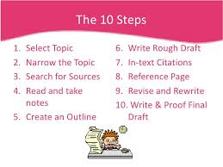
Process:
(Steps 1, 2, 3)
STEP 1: Narrowing and Focusing your Topic
Topic Choice: # ______
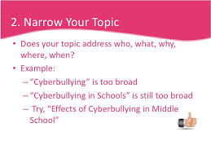
STEP 2: Previewing and Reading your Sources
You must choose a minimum of 4 sources. You may use more sources if you like.
You must preview the sources by looking at titles, headings, subheadings, tables of contents, abstracts, descriptors, etc. You can ask your instructor specific questions, about the sources, after you have previewed them, BUT it is NOT the instructor’s responsibility to preview the source.
This part of the process takes a lot of time. There is no short cut. You must be prepared to spend many hours reading at this stage.
Special Note on Previewing and Reading Sources (See Step 5 for more information)

When you preview your sources and when you begin critically reading your sources, you should ANNOTATE them. Below is an example of 1 annotation in a source. Each article should have many annotations.
See the PPT presentation on BlackBoard= Quoting Paraphrasing Summary APA slideplayer 9673274
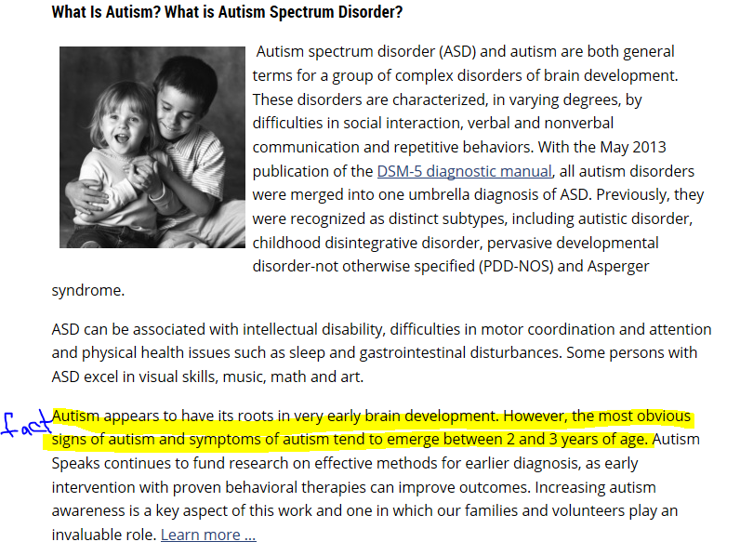

STEP 3: Writing a Thesis /Purpose Statement

(Steps 4, 5, 6, & 7)
STEP 4: The Preliminary Outline: This is just the beginning step to determine how or where to include ideas in your term paper. Later, your outline will be longer (especially in the Body).
Title: ____________________________________________________________________________
Thesis/Purpose Statement: Modify thesis statement as needed.
_________________________________________________________________________________
_________________________________________________________________________________
_________________________________________________________________________________
INTRODUCTION (opening statements, facts, figures, definitions, ‘hook’ etc.) Remember to write ONLY main ideas!

Body:
- (BACKGROUND) _______________________________________________________
  - ___________________________________________________________________
- ___________________________________________________________________
- ___________________________________________________________________

- ______________________________________________________________________
- ____________________________________________________________________
- ____________________________________________________________________
- ____________________________________________________________________

- ______________________________________________________________________
- ____________________________________________________________________
- ____________________________________________________________________
- ____________________________________________________________________

CONCLUSION (It can include your opinions, thoughts and ideas about what you have read and written.)

STEP 5: Writing Source and Information Note Cards
There are two types of note cards for your report: source note cards and information note cards.
Information note cards contain ideas and information from other sources. You will use the ideas you write on your note cards to write the rough draft of your report. It is therefore, important for you to write clear and concise notes.

See the PPT presentation on BlackBoard=
Quoting Paraphrasing Summary APA slideplayer 9673274

Sample Source Card:
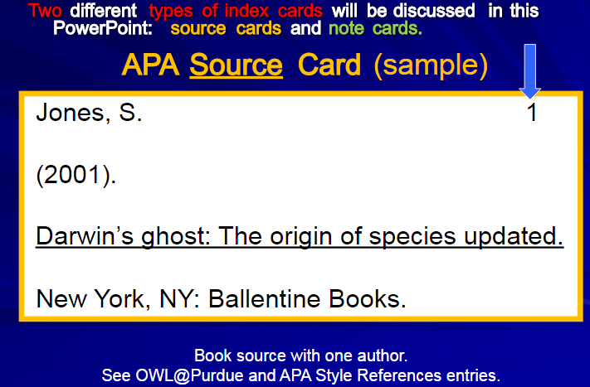

Sample Note Card:
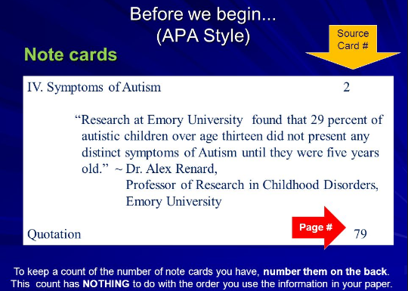

STEP 6: Final Outline
This is an example. For a term paper, the outline will be longer than this (especially in the Body) so you should write it on your own paper. Use this outline to help you write the Contents page of your term paper.
INTRODUCTION

- (BACKGROUND) _______________________________________________________
- ___________________________________________________________________
- ___________________________________________________________________
- ___________________________________________________________________
- ______________________________________________________________________
- ____________________________________________________________________
- ____________________________________________________________________
- ____________________________________________________________________
- ______________________________________________________________________
- ____________________________________________________________________
- ____________________________________________________________________
- ____________________________________________________________________
CONCLUSION

Get a copy of the TERM PAPER Template from Blackboard. Make sure you understand the template and can use it correctly.
STEP 7: Write the First Draft: Give to your instructor by the end of Week 10.
You must also submit all the sources to your supervisor.

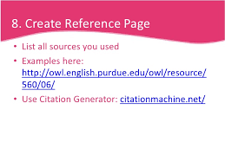

WEEK 12
STEP 8: Editing and Proofreading
STEP 9: Writing/revising/editing the Final Draft

WEEK 13
Give the Final revised and edited copy of your term paper to your instructor in Week 13. Don’t forget your sources.

Appendix 1: Instructions for the Turnitin Website
To get started, log in to www.turnitin.com
[If you are reading this on BlackBoard, you can click on the link below or copy and paste it into your web browser.] https://www.turnitin.com/newuser_join.asp?svr=03&session-id=a22deabec0548e9c9817bcbec9187790&lang=en_us&r=94.7114808226452

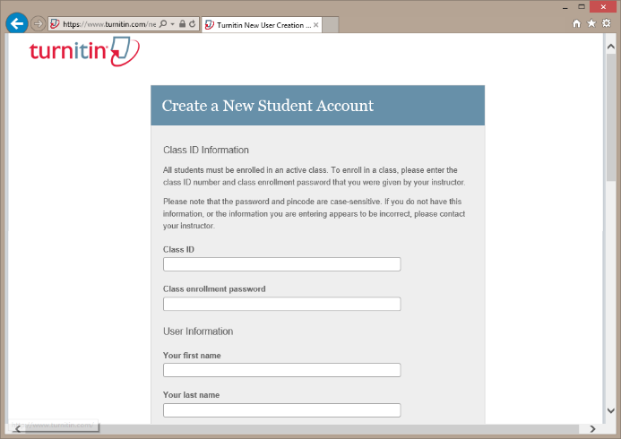
Step 1 - Registration
- To register and create a user profile, go to the top of the page and select your language from the drop down menu.
- Click on the 'Create Account' link on the homepage and the Create a User Profile page will open.
- Click on the 'Student' link. Fill in the required information in the new user profile form. In order to create a profile, you must have a class ID and an enrollment password. You can get this information from your instructor.

My Class ID __________________ My Enrollment password ________________

- Now fill in the other information. Remember to use your real name or you will be removed the class. [If you are working in a group, only 1 person in the group needs to make an account. However, all of you are responsible for the work/term paper that is uploaded.]
- Once you have created your profile, click the 'I Agree' button to log into Turnitin.
Step 2 - Student Homepage
Your class will show up on your Student Homepage. Click on the name of your class to open your class portfolio.
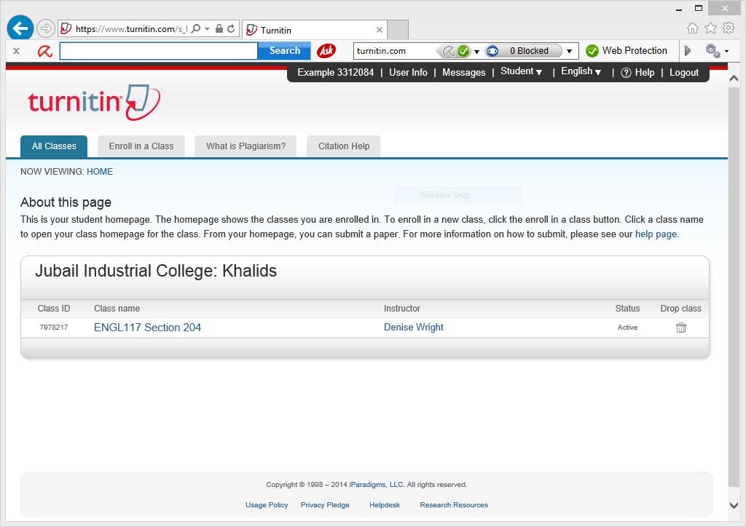
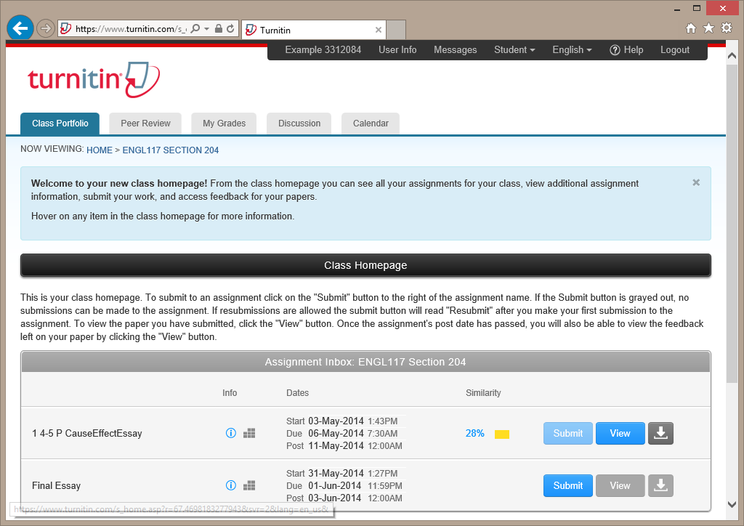
Step 3 - Class Homepage
Your Class Homepage shows the assignments your instructor has created and your submissions to the class.

Step 4 - Submitting a Paper
- To submit a paper, click the "Submit" button next to the paper assignment.
- The paper submission page will open. Enter a title for your paper.
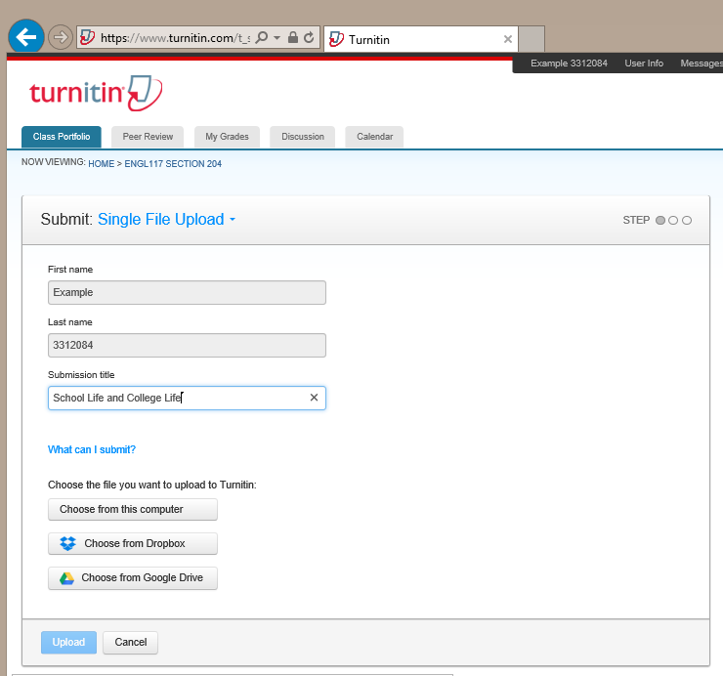
- Students have a choice to upload a file from: the computer, Dropbox, or Google Drive. Click on one of the submission buttons Choose from this computer, Choose from Dropbox, or Choose from Google Drive and select the file for submission.
- Turnitin accepts submissions in these formats:
Microsoft Word™ (DOC and DOCX)
Corel WordPerfect®
HTML
Adobe PostScript®
Plain text (TXT)
Rich Text Format (RTF)
Portable Document Format (PDF)
Microsoft PowerPoint (PPT, PPTX, and PPS)
Hangul (HWP)

- After entering a title for your paper and selecting a file, click 'Upload' to upload your paper.
- If your paper is in a format that Turnitin does not accept, you can submit it by cut and paste. To submit a paper this way, select cut & paste upload using the pulldown at the top of the form. Copy the text of your paper from a word processing program and then paste it into the text box in the submission form. If you submit your paper using the cut and paste method, you can skip the next step.
- If the assignment is set to accept any file type, students may upload any file type to the assignment.

Step 5 - Submitting a Paper Confirmation
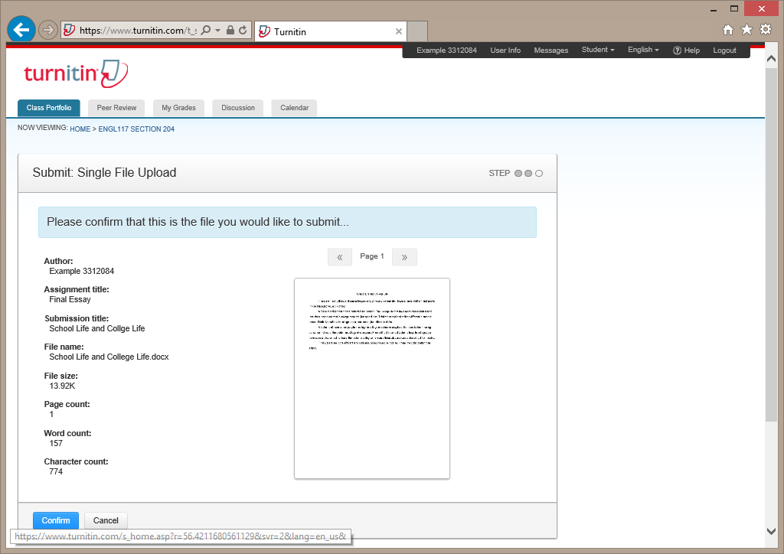
- The paper you chose to submit will be in the preview. Look over all the information and make sure that it is correct. To confirm the submission, click the 'Confirm' button.

- After you confirm your submission, a digital receipt will be shown. A copy of the receipt will be e-mailed to you. To return to your portfolio and view your submission, click the 'Return to assignment list' button.
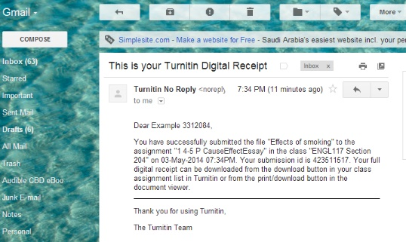

Step 6 - Viewing an Originality Report
- To view your Originality Report, click on the Originality icon (red box).
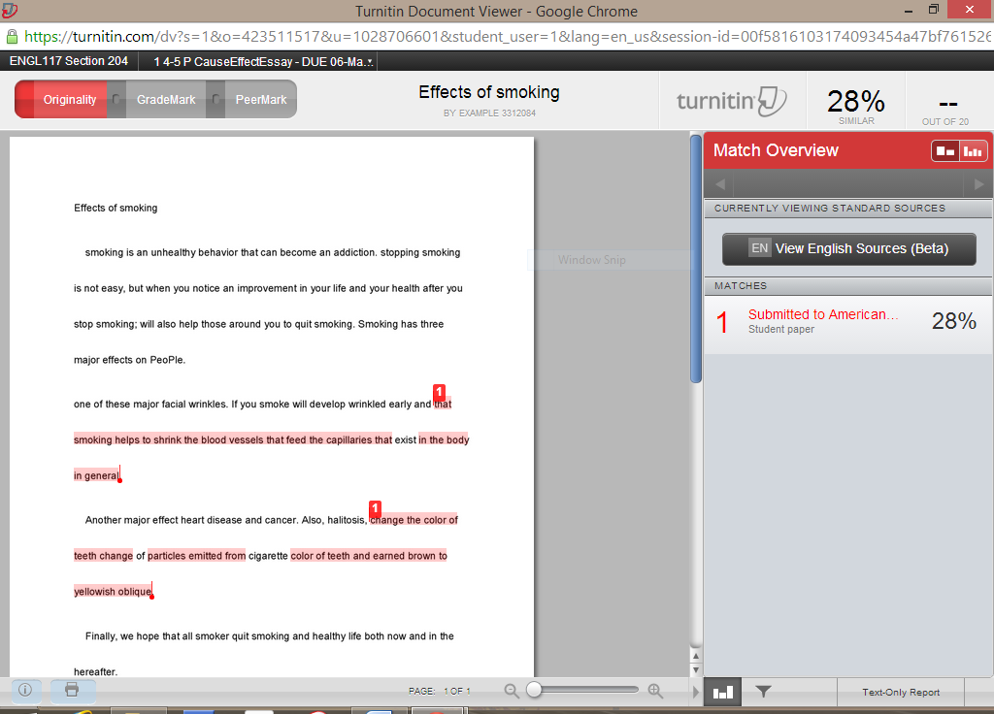
- By default, students cannot see their own Originality Reports. If you see the text 'Not Available' instead of an Originality Report icon in your portfolio, then your instructor has disabled the ability for students to view the Originality Report for this assignment. If you would like to view your report, contact your instructor.

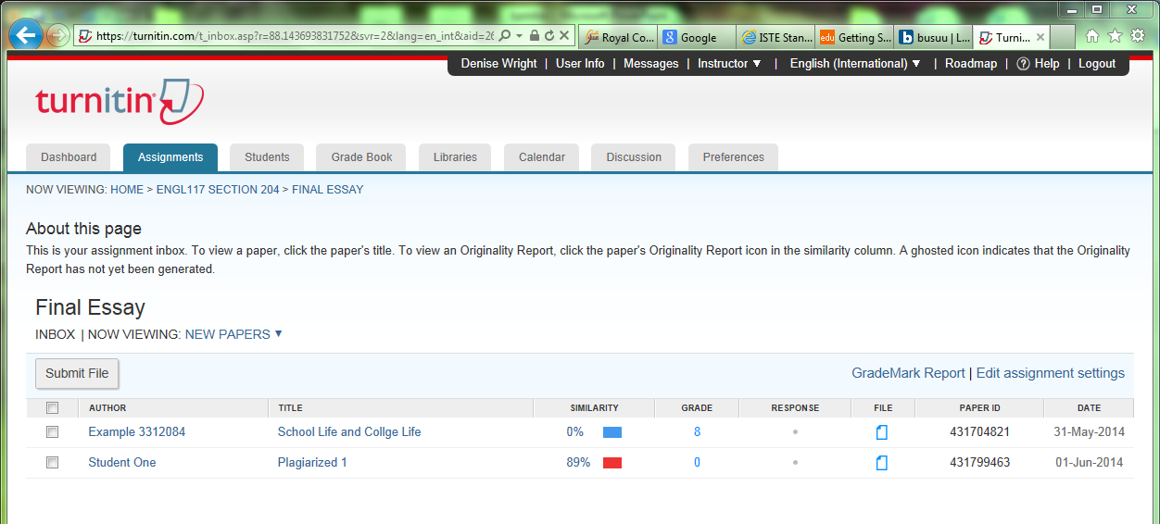

Step 7 - Viewing Instructor Feedback in GradeMark
- If the class instructor provided feedback on the assignment within GradeMark, students are able to view the feedback after the Post Date of the assignment.
- When the Post Date passes, students are able to access the instructor feedback within GradeMark by clicking on the blue 'View' button.

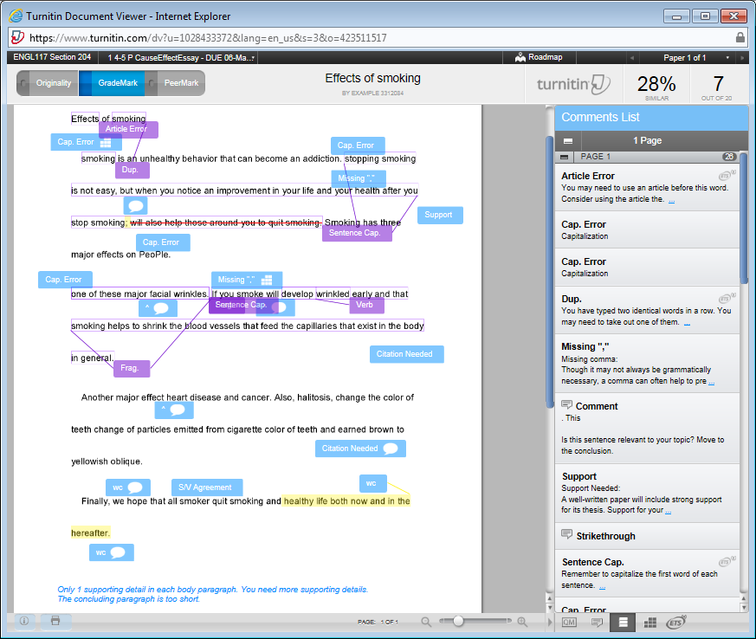

Note: The purple boxes are made by the computer grading system. The blue boxes and highlighting are made by your instructor.

